**Project Design Phase**

**Technology Stack (Architecture & Stack)**

|  |  |
| --- | --- |
| TEAM ID | PNT2022TMID26825 |
| PROJECT NAME | Real-Time River Water Quality Monitoring and Controlling System |

**TECHNICAL ARCHITECTURE**

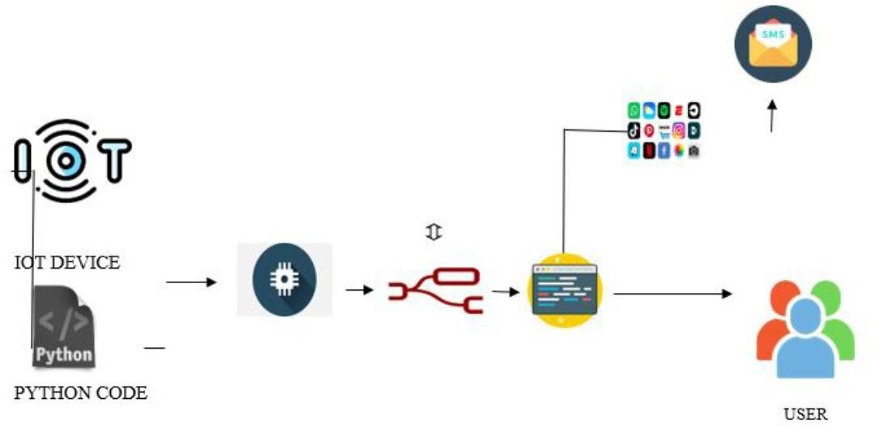

Table-1 : Components & Technologies:

|  |  |  |  |
| --- | --- | --- | --- |
| S.No | Component | Description | Technology |
| 1. | User Interface | How user interacts with application | HTML, CSS, Node-Red ,Cloud,etc |
| 2. | Application Logic-1 | Logic for a process in theapplication | JAVA/PYTHON |
| 3. | Application Logic-2 | Logic for a process in theapplication | IBM WATSON STT services |
| 4. | Application Logic-3 | Logic for a process in theapplication | BM WATSON Assistant |
| 5. | Database | Data Type, Configurations etc | MySQL, PostgresSQL |
| 6. | Cloud Database | Database Service on Cloud | IBM DB2,IBM Cloudant etc |
| 7. | File Storage | File storage requirements | IBM Block Storage or Other Storage Service or Local Filesystem |
| 8. | External API-1 | Purpose of External API used in the application | IBM Weather API, etc |
| 9. | External API-2 | Purpose of External API used in the application | Aadhar API, etc |
| 10. | Machine Learning Model | Purpose of External API used in the application | Object Recognition Model, etc.. |
| 11. | Infrastructure (Server / Cloud) | Application Deployment on Local System / Cloud  Local Server Configuration: Cloud Server Configuration | Local, Cloud Foundry, Kubernetes, etc. |

Table-2: Application Characteristics:-

|  |  |  |  |
| --- | --- | --- | --- |
| S.No | Characteristics | Description | Technology |
|  | Open-Source Frameworks | List the open-sourceframeworks used | Technology of Opensource framework |
| 2. | Security Implementations | List all the security / access controls implemented, use of firewalls etc | e.g. SHA-256, Encryptions, IAM Controls, OWASP etc. |
| 3. | Scalable Architecture | Justify the scalability of architecture (3 – tier, Micro- services) | Technology used |
| 4. | Availability | Justify the availability of application | Technology used |
| 5. | Performance | Design consideration for the performance of the application | Technology used |